**Chapter 3**

**SOFTWARE SPECIFICATION**

**3.1 Phantomjs 2.1.1**

PhantomJS is a scripted, headless browser used for automating web page interaction. PhantomJS provides a JavaScript API enabling automated navigation, screenshots, user behaviour and assertions making it a common tool used to run browser-based unit tests in a headless system like a continuous integration environment. PhantomJS is based on Webkit making it a similar browsing environment to Safari and Google Chrome (before Chrome's fork of Webkit evolved into Blink). It is Open Source Software released under the BSD License[12].



**Figure 3.1: PhantomJS logo**

The PhantomJS JavaScript API can be used to open web pages, take screenshots, execute user actions, and run injected JavaScript in the page context.

Since its release, Phantomjs has become a staple in the workflow of many JavaScript engineers. In the article titles “Headless Webkit and PhantomJS”, Colin Ihrig has introduced the concept of “Headless Webkit” and wrote a few words on PhantomJS. With over 11,000 stars on GitHub, PhantomJS has become the go-to tool for developers, especially when dealing with testing their code. PhantomJS is a web browser that exists only in script [12]. There is no GUI, but rather a headless browser that can automate different processes with JavaScript.

**3.1.1 Page Automation**

PhantomJS allows developers to access the browser’s DOM API. After all, PhantomJS is still a browser even if it hasn’t a GUI. Developers can write JavaScript code that will be evaluated against a specified page. Although this may not seem very important, this allows us to automate any sort of interactions with a web page without having to open a browser (operation that will save you a tremendous amount of time). This is helpful especially when using PhantomJS to run tests.

**3.1.2** **Screen Capture**

By utilizing Webkit, PhantomJS provides the ability to render any content on a web page and save it as an image. Therefore, it can be used to automate the process of capturing screenshots of web pages that developers can analyse to ensure that everything looks good. These images can be saved in several formats such as PNG, JPEG, PDF, and GIF. PhantomJS also allows developers to adjust the size of these screenshots, and specify the exact areas that we want to capture.

**3.1.3 Testing**

PhantomJS helps developers to automate the process of running tests without a need for any sort of GUI. PhantomJS makes use of its headless browser to handle different unit tests instead, and uses the command line to tell developers where they are running into error. There is no doubt that PhantomJS is primarily known for its use in testing; however, it’s worth noting that it isn’t a testing framework. In development, PhantomJS is used to launch different tests frameworks.

PhantomJS is also used in continuous integration systems. For those who are unfamiliar with the process of continuous integration, it deals with a way to monitor your application. Developers can integrate PhantomJS with CI systems (such as Travis CI ) in order to run tests on any new code being added to a project, before actually pushing the code. As a result, developers are able to detect problems in code as soon as they arise, and fix them, thus ensuring that no broken code will be pushed to the project.

**3.1.4 Network Monitoring**

Another core feature of PhantomJS is its ability to monitor the network connection. As defined in the documentation:

“Because PhantomJS permits the inspection of network traffic, it is suitable to build various analysis on the network behavior and performance.”[13]

This means that PhantomJS can be programmed to collect different data about the performance of a web page. When paired with PhantomJS, YSlow can output the results from these tests using different formats (TAP, for example). When implemented, TAP allows communication between unit tests, and a testing harness, which in this case would be PhantomJS. Additionally, PhantomJS and YSlow make use of TAP protocol in continuous integration systems, and monitor the performance of new code being added to a project. In this way, developers can be informed of any regression in performance before the code is pushed.

**3.2 OpenCV 2.4.10**

OpenCV (Open Source Computer Vision) is a library of programming functions mainly aimed at real-time computer vision originally developed by Intel’s research centre in Nizhny Novgorod(Russia), later supported by Willow Garage and now maintained by Itseez [14]. The library is cross-platform and free for use under the open-source BSD License.



**Figure 3.2 : Open source Computer Vision Library**

Officially launched in 1999, the OpenCV project was initially an Intel Research initiative to advance CPU-intensive applications, part of a series of projects including real-time ray tracing and 3D display walls[15]. The main contributors to the project included a number of optimization experts in Intel Russia, as well as Intel’s Performance Library Team. In the early days of OpenCV, the goals of the project were described as:

1. Advance vision research by providing not only open but also optimized code for basic vision infrastructure. No more reinventing the wheel.

1. Disseminate vision knowledge by providing a common infrastructure that developers could build on, so that code would be more readily readable and transferable.

Advance vision-based commercial applications by making portable, performance-optimized code available for free—with a license that did not require being open or freeing them.

The first alpha version of OpenCV was released to the public at the IEEE Conference on Computer Vision and Pattern Recognition in 2000, and five betas were released between 2001 and 2005. The first 1.0 version was released in 2006. In mid-2008, OpenCV obtained corporate support from Willow Garage, and is now again under active development. A version 1.1 "pre-release" was released in October 2008[15].

The second major release of the OpenCV was on October 2009. OpenCV 2 includes major changes to the C++ interface, aiming at easier, more type-safe patterns, new functions and better implementations for existing ones in terms of performance (especially on multi-core systems). Official releases now occur every six months and development is now done by an independent Russian team supported by commercial corporations. In August 2012, support for OpenCV was taken over by a non-profit foundation OpenCV.org, which maintains a developer and user site[16].

The library has more than 2500 optimized algorithms, which includes a comprehensive set of both classic and state-of-the-art computer vision and machine learning algorithms [16]. These algorithms can be used to detect and recognize faces, identify objects, classify human actions in videos, track camera movements, track moving objects, extract 3D models of objects, produce 3D point clouds from stereo cameras, stitch images together to produce a high resolution image of an entire scene, find similar images from an image database, remove red eyes from images taken using flash, follow eye movements, recognize scenery and establish markers to overlay it with augmented reality, etc. OpenCV has more than 47 thousand people of user community and estimated number of downloads exceeding 7 million[15,16]. The library is used extensively in companies, research groups and by governmental bodies.

Along with well-established companies like Google, Yahoo, Microsoft, Intel, IBM, Sony, Honda, Toyota that employ the library, there are many start-ups such as Applied Minds, VideoSurf, and Zeitera, that make extensive use of OpenCV. OpenCV’s deployed uses span the range from stitching street view images together, detecting intrusions in surveillance video in Israel, monitoring mine equipment in China, helping robots navigate and pick up objects at Willow Garage, detection of swimming pool drowning accidents in Europe, running interactive art in Spain and New York, checking runways for debris in Turkey, inspecting labels on products in factories around the world on to rapid face detection in Japan [15].

**3.2.1 Applications**

OpenCV's application areas include:

1. 2D and 3D feature toolkits

2. Egomotion estimation

3. Facial recognition system

4. Gesture recognition

5. Human–computer interaction (HCI)

6. Mobile robotics

7. Motion understanding

8. Object identification

9. Segmentation and recognition

10. Stereopsis stereo vision: depth perception from 2 cameras

11. Structure from motion (SFM)

12. Motion tracking

13. Augmented reality

To support some of the above areas, OpenCV includes a statistical machine learning library that contains:

1. Boosting

2. Decision tree learning

3. Gradient boosting trees

4. Expectation-maximization algorithm

5. k-nearest neighbour algorithm

6. Naive Bayes classifier

7. Artificial neural networks

8. Random forest

9. Support vector machine (SVM)

**3.3 Ubuntu LTS 14.04.1**

Ubuntu is a Debian-based Linux operating system and distribution for personal computers, smart phones and network servers. It uses Unity as its default user interface. It is based on free software and named after the Southern African philosophy of ubuntu (literally, "human-ness"), which often is translated as "humanity towards others" or "the belief in a universal bond of sharing that connects all humanity"[17].

Development of Ubuntu is led by UK-based Canonical Ltd., a company owned by South African entrepreneur Mark Shuttleworth. Canonical generates revenue through the sale of technical support and other services related to Ubuntu. The Ubuntu project is publicly committed to the principles of open-source software development.



**Figure 3.3 : Ubuntu Logo**

Ubuntu is built on Debian's architecture and infrastructure, to provide Linux server, desktop, phone, tablet and TV operating systems. Ubuntu releases updated versions predictably every six months, and each release receives free support for nine months (eighteen months prior to 13.04) with security fixes, high-impact bug fixes and conservative, substantially beneficial low-risk bug fixes. The first release was in October 2004 [17].

It was decided that every fourth release, issued on a two-year basis, would receive long-term support (LTS). Long-term support includes updates for new hardware, security patches and updates to the 'Ubuntu stack' (cloud computing infrastructure). The first LTS releases were supported for three years on the desktop and five years on the server; since Ubuntu 12.04 LTS, desktop support for LTS releases was increased to five years as well. LTS releases get regular point releases with support for new hardware and integration of all the updates published in that series to date.

Ubuntu packages are based on packages from Debian's unstable branch. Both distributions use Debian's deb package format and package management tools (APT and Ubuntu Software Center). Debian and Ubuntu packages are not necessarily binary compatible with each other,

However, packages may need to be rebuilt from source to be used in Ubuntu. Many Ubuntu developers are also maintainers of key packages within Debian. Ubuntu cooperates with Debian by pushing changes back to Debian, although there has been criticism that this does not happen often enough. Ian Murdock, the founder of Debian, has expressed concern about Ubuntu packages potentially diverging too far from Debian to remain compatible. Before release, packages are imported from Debian Unstable continuously and merged with Ubuntu-specific modifications. One month before release, imports are frozen, and packagers then work to ensure that the frozen features interoperate well together.

Ubuntu is currently funded by Canonical Ltd. On 8 July 2005, Mark Shuttleworth and Canonical Ltd., announced the creation of the Ubuntu Foundation and provided an initial funding of US$10 million[18]. The purpose of the foundation is to ensure the support and development for all future versions of Ubuntu. Mark Shuttleworth describes the foundation as an "emergency fund"; which in such a case, Canonical's involvement ends[18].

On 12 March 2009, Ubuntu announced developer support for 3rd-party cloud management platforms, such as those used at Amazon EC2. Unity has become the default GUI for Ubuntu Desktop[18].

Ubuntu's goal is to be secure "out-of-the box". By default, the user's programs run with low privileges and cannot corrupt the operating system or other users' files. For increased security, the sudo tool is used to assign temporary privileges for performing administrative tasks, which allows the root account to remain locked and helps prevent inexperienced users from inadvertently making catastrophic system changes or opening security holes. Policy Kit is also being widely implemented into the desktop to further harden the system. Most network ports are closed by default to prevent hacking. A built-in firewall allows end-users who install network servers to control access. A GUI (GUI for Uncomplicated Firewall) is available to configure it. Ubuntu compiles its packages using GCC features such as PIE and buffer overflow protection to harden its software. These extra features greatly increase security at the performance expense of 1% in 32 bit and 0.01% in 64 bit. The home and Private directories can be encrypted.

**3.4 Java version "1.7.0_95"**

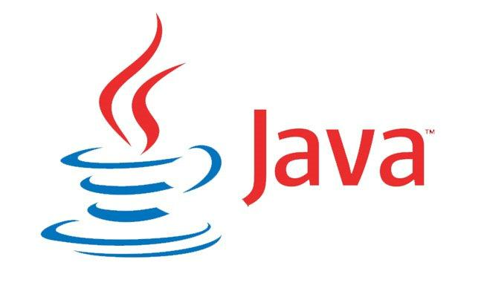Java is a general-purpose computer programming language that is concurrent, class-based, object-oriented, and specifically designed to have as few implementation dependencies as possible. It is intended to let application developers "write once, run anywhere" (WORA), meaning that compiled Java code can run on all platforms that support Java without the need for recompilation. Java applications are typically compiled to byte code that can run on any Java virtual machine (JVM) regardless of computer architecture. As of 2016, Java is one of the most popular programming languages in use, particularly for client-server web applications, with a reported 9 million developers. Java was originally developed by James Gosling at Sun Microsystems (which has since been acquired by Oracle Corporation) and released in 1995 as a core component of Sun Microsystems' Java platform. The language derives much of its syntax from C and C++, but it has fewer low-level facilities than either of them[19].

|  |  |  |  |  |
| --- | --- | --- | --- | --- |
|  |  |  |  |  |
|  |  |  |  |  |

**Figure 3.4 : Java logo**

The original and reference implementation Java compilers, virtual machines, and class libraries were originally released by Sun under proprietary licences. As of May 2007, in compliance with the specifications of the Java Community Process, Sun relicensed most of its Java technologies under the GNU General Public License [19]. Others have also developed alternative implementations of these Sun technologies, such as the GNU Compiler for Java (byte code compiler), GNU Class path (standard libraries), and IcedTea-Web (browser plug-in for applets).

The latest version is Java 8, which is the only version currently supported for free by Oracle, although earlier versions are supported both by Oracle and other companies on a commercial basis.

There were five primary goals in the creation of the Java language:

* 1. It must be "simple, object-oriented, and familiar".
  2. It must be "robust and secure".
  3. It must be "architecture-neutral and portable".
  4. It must execute with "high performance".
  5. It must be "interpreted, threaded, and dynamic".

**3.4.1 Versions**

As of 2015, only Java 8 is supported ("publicly"). Major release versions of Java, along with their release dates:

1. JDK 1.0 (January 21, 1996)

2. JDK 1.1 (February 19, 1997)

3. J2SE 1.2 (December 8, 1998)

4. J2SE 1.3 (May 8, 2000)

5. J2SE 1.4 (February 6, 2002)

6. J2SE 5.0 (September 30, 2004)

7. Java SE 6 (December 11, 2006)

8. Java SE 7 (July 28, 2011)

9. Java SE 8 (March 18, 2014)

**3.5 MySQL**

MySQL is an open-source relational database management system (RDBMS) in July 2013[**N**], it was the world's second most widely used RDBMS, and the most widely used open-source client–server model RDBMS. It is named after Michael Widenius’ (who is a co-founder of MySQL) daughter, My, while "SQL" stands as the abbreviation for Structured Query Language [20]. The MySQL development project has made its source code available under the terms of the GNU General Public License, as well as under a variety of proprietary agreements. MySQL was owned and sponsored by a single for-profit firm, the Swedish company MySQL AB, now owned by Oracle Corporation. For proprietary use, several paid editions are available, and offer additional functionality.

MySQL is a popular choice of database for use in web applications, and is a central component of the widely used LAMP open-source web application software stack (and other "AMP" stacks). LAMP is an acronym for "Linux, Apache, MySQL, Perl/PHP/Python". Free-software open-source projects that require a full-featured database management system often use MySQL.

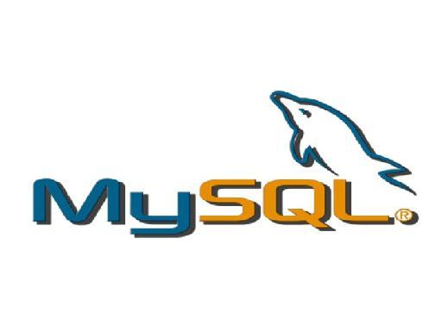

**Figure 3.5: MySQL Logo**

Applications that use the MySQL database include: TYPO3, MODx, Joomla, PhpBB, MyBB, Drupal and other software.

MySQL is also used in many high-profile, large-scale websites, including Google (though not for searches), Facebook, Twitter, Flickr, and YouTube[21].

On all platforms except Windows, MySQL ships with no GUI tools to administer MySQL databases or manage data contained within the databases. Users may use the included command line tools, or install MySQL Workbench via a separate download. Many third party GUI tools are also available.

**3.5.1 Versions**

The following chart provides an overview of various MySQL versions and their development statuses:

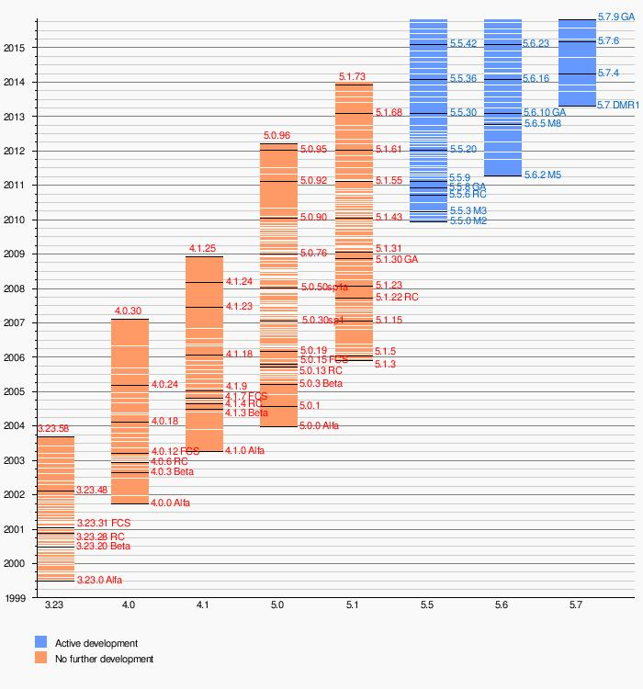

**Figure 3.5.1 :MySQL versions and its development statuses**

**3.5.2 Features**

* **Scalability and Flexibility**

The MySQL database server provides the ultimate in scalability, sporting the capacity to handle deeply embedded applications with a footprint of only 1MB to running massive data warehouses holding terabytes of information. Platform flexibility is a stalwart feature of MySQL with all flavors of Linux, UNIX, and Windows being supported. And, of course, the open source nature of MySQL allows complete customization for those wanting to add unique requirements to the database server.

* **High Performance**

A unique storage-engine architecture allows database professionals to configure the MySQL database server specifically for particular applications, with the end result being amazing performance results. Whether the intended application is a high-speed transactional processing system or a high-volume web site that services a billion queries a day, MySQL can meet the most demanding performance expectations of any system. With high-speed load utilities, distinctive memory caches, full text indexes, and other performance-enhancing mechanisms, MySQL offers all the right ammunition for today's critical business systems.

* **High Availability**

Rock-solid reliability and constant availability are hallmarks of MySQL, with customers relying on MySQL to guarantee around-the-clock uptime. MySQL offers a variety of high-availability options from high-speed master/slave replication configurations, to specialized Cluster servers offering instant failover, to third party vendors offering unique high-availability solutions for the MySQL database server.

* **Robust Transactional Support**

MySQL offers one of the most powerful transactional database engines on the market. Features include complete ACID (atomic, consistent, isolated, durable) transaction support, unlimited row-level locking, distributed transaction capability, and multi-version transaction support where readers never block writers and vice-versa. Full data integrity is also assured through server-enforced referential integrity, specialized transaction isolation levels, and instant deadlock detection.

* **Web and Data Warehouse Strengths**

MySQL is the de-facto standard for high-traffic web sites because of its high-performance query engine, tremendously fast data insert capability, and strong support for specialized web functions like fast full text searches. These same strengths also apply to data warehousing environments where MySQL scales up into the terabyte range for either single servers or scale-out architectures. Other features like main memory tables, B-tree and hash indexes, and compressed archive tables that reduce storage requirements by up to eighty-percent make MySQL a strong standout for both web and business intelligence applications.

* **Strong Data Protection**

Because guarding the data assets of corporations is the number one job of database professionals, MySQL offers exceptional security features that ensure absolute data protection. In terms of database authentication, MySQL provides powerful mechanisms for ensuring only authorized users have entry to the database server, with the ability to block users down to the client machine level being possible. SSH and SSL support are also provided to ensure safe and secure connections. A granular object privilege framework is present so that users only see the data they should, and powerful data encryption and decryption functions ensure that sensitive data is protected from unauthorized viewing. Finally, backup and recovery utilities provided through MySQL and third party software vendors allow for complete logical and physical backup as well as full and point-in-time recovery.

* **Comprehensive Application Development**

One of the reasons MySQL is the world's most popular open source database is that it provides comprehensive support for every application development need. Within the database, support can be found for stored procedures, triggers, functions, views, cursors, ANSI-standard SQL, and more. For embedded applications, plug-in libraries are available to embed MySQL database support into nearly any application. MySQL also provides connectors and drivers (ODBC, JDBC, etc.) that allow all forms of applications to make use of MySQL as a preferred data management server. It doesn't matter if it's PHP, Perl, Java, Visual Basic, or .NET, MySQL offers application developers everything they need to be successful in building database-driven information systems.

* **Management Ease**

MySQL offers exceptional quick-start capability with the average time from software download to installation completion being less than fifteen minutes. This rule holds true whether the platform is Microsoft Windows, Linux, Macintosh, or UNIX. Once installed, self-management features like automatic space expansion, auto-restart, and dynamic configuration changes take much of the burden off already overworked database administrators. MySQL also provides a complete suite of graphical management and migration tools that allow a DBA to manage, troubleshoot, and control the operation of many MySQL servers from a single workstation. Many third party software vendor tools are also available for MySQL that handle tasks ranging from data design and ETL, to complete database administration, job management, and performance monitoring.

* **Open Source Freedom and 24 x 7 Support**

Many corporations are hesitant to fully commit to open source software because they believe they can't get the type of support or professional service safety nets they currently rely on with proprietary software to ensure the overall success of their key applications. The questions of indemnification come up often as well. These worries can be put to rest with MySQL as complete around-the-clock support as well as indemnification is available through MySQL Enterprise. MySQL is not a typical open source project as all the software is owned and supported by Oracle, and because of this, a unique cost and support model are available that provides a unique combination of open source freedom and trusted software with support.

* **Lowest Total Cost of Ownership**

By migrating current database-drive applications to MySQL, or using MySQL for new development projects, corporations are realizing cost savings that many times stretch into seven figures. Accomplished through the use of the MySQL database server and scale-out architectures that utilize low-cost commodity hardware, corporations are finding that they can achieve amazing levels of scalability and performance, all at a cost that is far less than those offered by proprietary and scale-up software vendors. In addition, the reliability and easy maintainability of MySQL means that database administrators don't waste time troubleshooting performance or downtime issues, but instead can concentrate on making a positive impact on higher level tasks that involve the business side of data.

**3.6 Google Maps APIs:**

Google Maps is a desktop web mapping service developed by Google. It offers satellite imagery, street maps, 360° panoramic views of streets (Street View), real-time traffic conditions (Google Traffic), and route planning for traveling by foot, car, bicycle (inbeta), or public transportation.

Google Maps began as a C++ desktop program designed by Lars and Jens Eilstrup Rasmussen at Where 2 Technologies. In October 2004, the company was acquired by Google, which converted it into a web application. After additional acquisitions of a geospatial data visualization company and a real-time traffic analyzer, Google Maps was launched in February 2005 [22] . The service's front end utilizes JavaScript, XML, and Ajax. Google Maps offers an API that allows maps to be embedded on third-party websites, and offers a locator for urban businesses and other organizations in numerous countries around the world. Google Map Maker allows users to collaboratively expand and update the service's mapping worldwide.

Google Maps' satellite view is a "top-down" or "birds eye" view; most of the high-resolution imagery of cities is aerial photography taken from aircraft flying at 800 to 1,500 feet (240 to 460 m), while most other imagery is from satellites[23]. Much of the available satellite imagery is no more than three years old and is updated on a regular basis, Google Maps uses a close variant of the Mercator projection, and therefore cannot accurately show areas around the poles.

**Fig 3.6: Google maps logo**

The current redesigned version of the desktop application was made available in 2013, alongside the "classic" (pre-2013) version. Google Maps for mobile was released in September 2008 and features GPS turn-by-turn navigation. In August 2013, it was determined to be the world's most popular app for Smart phones, with over 54% of global Smartphone owners using it at least once[22].

In 2012, Google reported of having over 7,100 employees and contractors directly working in mapping[21].

Like many other Google web applications, Google Maps uses JavaScript extensively. As the user drags the map, the grid squares are downloaded from the server and inserted into the page. When a user searches for a business, the results are downloaded in the background for insertion into the side panel and map the page is not reloaded. Locations are drawn dynamically by positioning a red pin (composed of several partially transparent PNGs) on top of the map images. A hidden IFrame with form submission is used because it preserves browser history. The site also uses JSON for data transfer rather than XML, for performance reasons. These techniques both fall under the broad Ajax-umbrella. The result is termed a slippy map and is implemented elsewhere in projects such as OpenLayers.

In October 2011, Google announced MapsGL, a WebGL version of Maps with better renderings and smoother transitions [24].

After the success of reverse-engineered mashups such as chicagocrime.org and housingmaps.com, Google launched the Google Maps API in June 2005 to allow developers to integrate Google Maps into their websites. It is a free service, and currently does not contain ads, but Google states in their terms of use that they reserve the right to display ads in the future [23].

By using the Google Maps API, it is possible to embed Google Maps site into an external website, on to which site specific data can be overlaid. Although initially only a JavaScript API, the Maps API was expanded to include an API for Adobe Flash applications (but this has been deprecated), a service for retrieving static map images, and web services for performing geocoding, generating driving directions, and obtaining elevation profiles. Over 1,000,000 websites use the Google Maps API, making it the most heavily used web application development API [22].

The Google Maps API is free for commercial use, provided that the site on which it is being used is publicly accessible and does not charge for access, and is not generating more than 25000 map accesses a day. Sites that do not meet these requirements can purchase the Google Maps API for Business[22].

The success of the Google Maps API has spawned a number of competing alternatives, including the HERE Maps API, Bing Maps Platform, Leaflet and OpenLayers via self-hosting. The Yahoo! Maps API is in the process of being shut down.

**3.7 GSL-GNU Scientific Library:**

The GNU Scientific Library (GSL) is a numerical library for C and C++ programmers. It is free software under the GNU General Public License.

The library provides a wide range of mathematical routines such as random number generators, special functions and least-squares fitting. There are over 1000 functions in total with an extensive test suite.[25]

The GSL project was initiated in 1996 by physicists Mark Galassi and James Theiler of Los Alamos National Laboratory. They aimed at writing a modern replacement for widely used but somewhat outdated Fortran libraries such as Netlib[25]. They carried out the overall design and wrote early modules; with that ready they recruited other scientists to contribute.

The "overall development of the library and the design and implementation of the major modules" was carried out by Brian Gough and Gerard Jungman. Other major contributors were Jim Davies, Reid Priedhorsky, M. Booth, and F. Rossi [26].

Version 1.0 was released in 2001. The library continues to be actively developed and version 2.1 was released on November 11, 2015[26].

The complete range of subject areas covered by the library includes,

|  |  |
| --- | --- |
| Complex Numbers | Roots of Polynomials |
| Special Functions | Vectors and Matrices |
| Permutations | Sorting |
| BLAS Support | Linear Algebra |
| Eigensystems | Fast Fourier Transforms |
| Quadrature | Random Numbers |
| Quasi-Random Sequences | Random Distributions |
| Statistics | Histograms |
| N-Tuples | Monte Carlo Integration |
| Simulated Annealing | Differential Equations |
| Interpolation | Numerical Differentiation |
| Chebyshev Approximation | Series Acceleration |
| Discrete Hankel Transforms | Root-Finding |
| Minimization | Least-Squares Fitting |
| Physical Constants | IEEE Floating-Point |
| Discrete Wavelet Transforms | Basis splines |
| Running Statistics | Sparse Matrices and Linear Algebra |

Unlike the licenses of proprietary numerical libraries the license of GSL does not restrict scientific cooperation

**3.7 Google Charts:**

The **Google Chart API** is a tool that lets people easily create a chart from some data and embed it in a web page. Google creates a PNG image of a chart from data and formatting parameters in an HTTP request. Many types of charts are supported, and by making the request into an image tag, people can simply include the chart in a web page.

Originally it was an internal tool to support rapid embedding of charts within Google's own applications (like Google Finance for example). Google figured it would be a useful tool to open up to web developers. It officially launched on December 6, 2007[27].

Currently, line, bar, pie, and radar charts, as well as Venn diagrams, scatter plots, sparklines, maps, google-o-meters, and QR codes are supported.

This API was deprecated in 2012 with guaranteed availability until April 2015. After that period, Google reserves the right to turn it off without notice, although as of April 2016, there are no plans to do so. The alternative recommended by Google is Google Charts [27].

**3.8 Summary**

This chapter discuss about the software and the libraries used for the development of the application and its advantages.